1. Write a program to place Name, Age and mobile number linearly (Vertical) on the display screen using Linear layout.
2. Write a program to display 10 students’ basic information in a table form using Table layout.
3. Write a program to accept and display personal information of the student.
4. Write a program to create a simple calculator.
5. Write a program to create a login form for student registration system.
6. Write a program to show five checkboxes and toast selected checkboxes.
7. 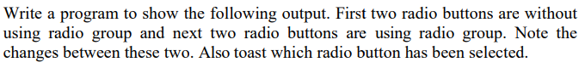

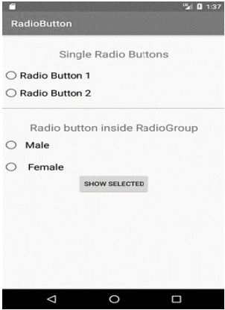

1. Write a 2. Write a program to display circular progress bar.
2. 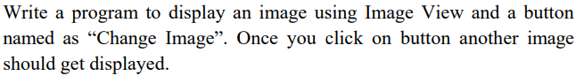
3. 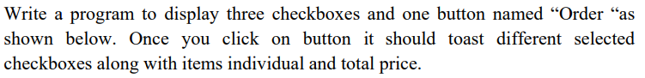
4. 
5. Write a program to create a HelloWorld Activity using all lifecycles methods to display messages using Log.d.
6. Write a program to create a text field and a button “Navigate”. When you enter “www.google.com” and press navigate button it should open google page.
7. Write a program to demonstrate all the system broadcast messages.
8. Write a program to changes the background color when device is shuffled.
9. Write a program to capture an image and display it using image view.
10. Write a program to create the login form and display login successful/ Unsuccessful toastmessage.
11. Write a program to create the login form with necessary validations like length of username and password, empty text fields, count of unsuccessful login attempts. Display the login successful/Unsuccessful toastmessage.
12. Write a Program to send and Receive SMS.